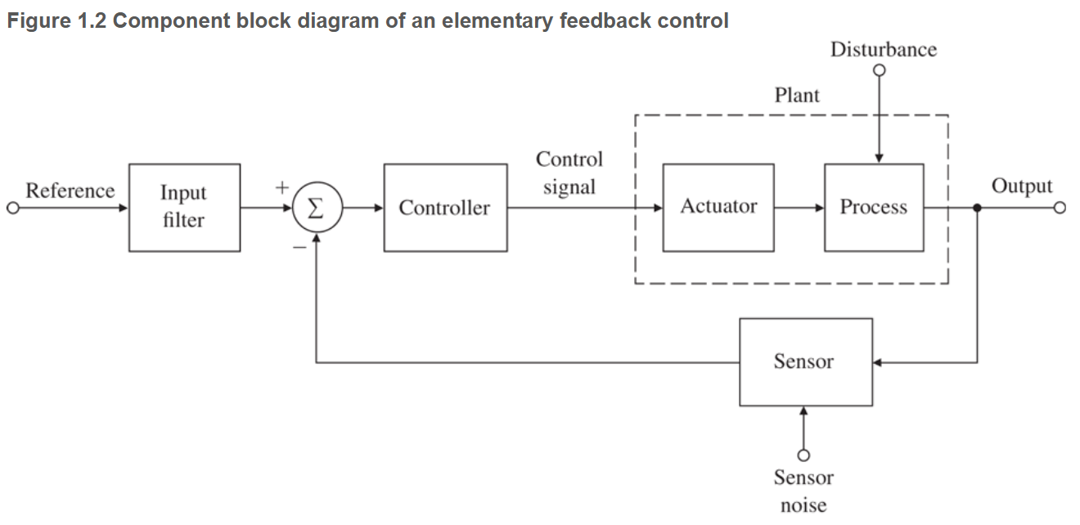

Given that the input is $ae^{s_{1}t}$ to a LTI system with impulse response, $H\left(s\right)$ what is the output $y\left(t\right)$? $y\left(t\right)=αH\left(s_{1}\right)e^{s_{1}t}$

$t_{r}=rise time$ (how long from 10% to 90% of final value)
$t_{p}=peak time$ (time to peak)
$M_{p}=overshoot$ (diff of peak to steady state, % of final value)
$$ζ=damp ratio \left(big=more damp\right)$$
$$ω_{n}=undamped nat freq$$
$$σ=damp factor \left(decay rate\right)$$
$$ω_{d}=damped nat freq$$
$$t_{r}=\frac{1.8}{ω_{n}}$$
$$t_{p}=\frac{π}{ω_{d}}$$
$$M_{p}=e^{-\frac{πζ}{\sqrt{1-ζ^{2}}}}$$
$$ζ=-\frac{ln\left(M_{p}\right)}{\sqrt{π^{2}+\ln^{2}{M_{p}}}}$$
$$t_{s}=\frac{4.6}{ζω_{n}}=\frac{4.6}{σ}\left(for 1\% settling time\right)$$
$$θ=Sin^{-1}ζ$$
$$ω_{d}=ω_{n}\sqrt{1-ζ^{2}}$$
$$H\left(s\right)=\frac{Kω_{n}^{2}}{s^{2}+2ζω_{n}s+ω_{n}^{2}}(std form 2order TF)$$
$$σ=ζω_{n}$$
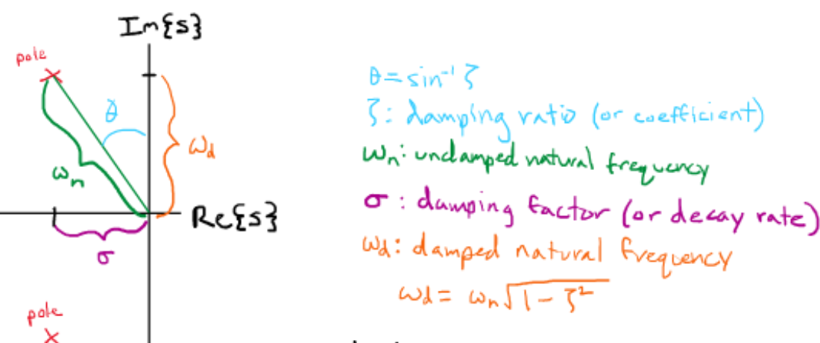
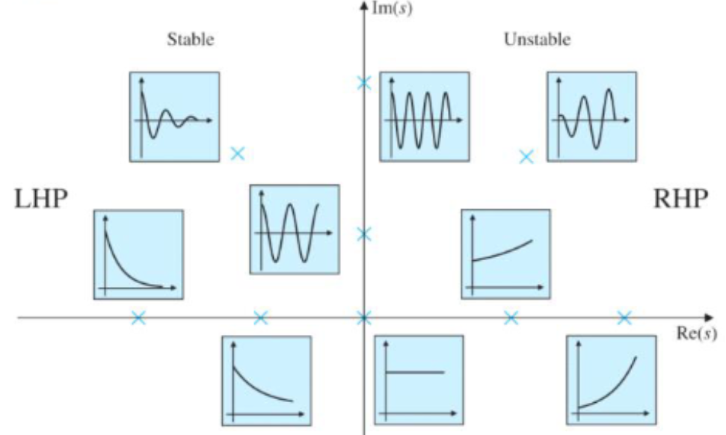
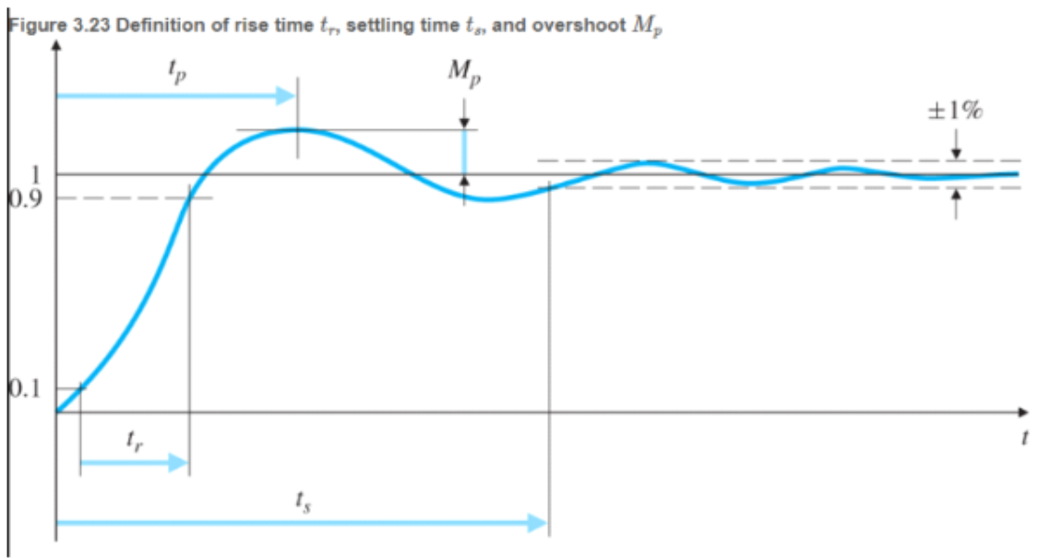
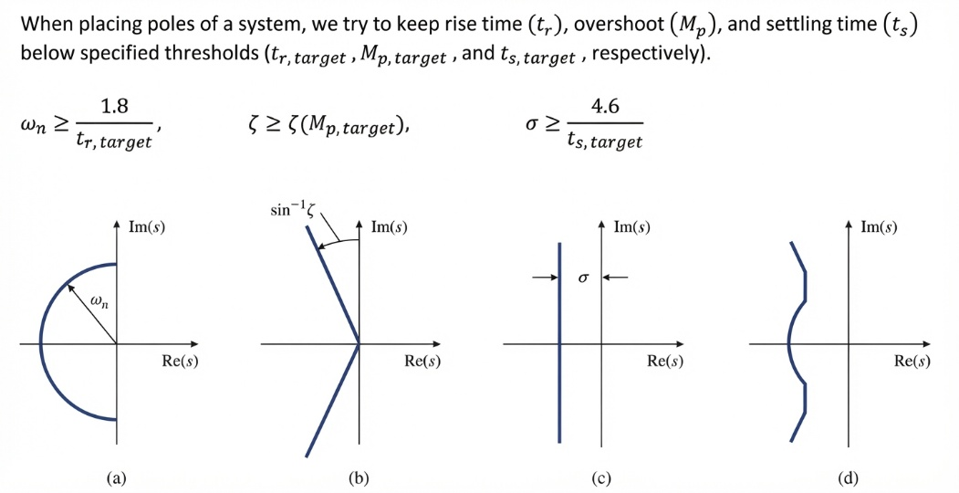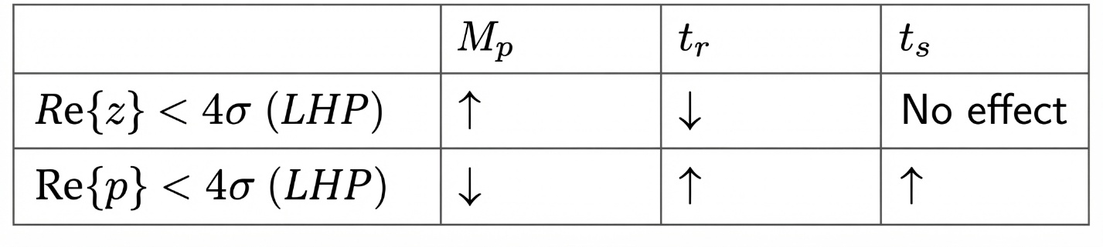
If it's a Pole closer to the origin: The system becomes slower.
If it's a Zero closer to the origin: The system's transient response becomes faster
Pole / Zero in LHP far from origin = insignificant
Faster Response: Smaller rise time, Shorter settling time
Slower Response: Larger rise time, Longer settling time

Odd # of zeros in RHP = undershoot
Even # of zeros in RHP = no undershoot
Unstable = { any poles in RHP; more than one point at origin; pole on im axis but not at origin (marginally stable)}
Unity feedbach = nothing in feedback loop
Routh array $→$can know if system is stable, and how many poles there are in RHP. At first glance, if ANY neg coeffs, it’s unstable. If all pos, could still be RHP. #poles in RHP = #sign changes in first row of routh array. Ex: 1,3,-7,8 = 2 sign changes, from + to – then - to +. To construct array, use leftmost column, and two rows above target. Then use column directly to the right of target value. $\frac{\left(bottom_{Left}\right)\left(Top_{Right}\right)-(Top_{Left})(Bottom_{Right})}{Bottom_{Left}}$
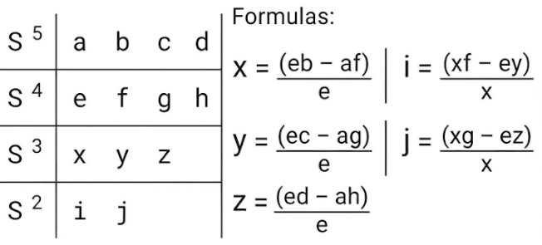

Final value theorem: $y\left(∞\right)=\lim_{s→0}{sH(s)}$
DC Gain Theorem (assuming input is unit step, if apply unit step, what will final value be?):
DC Gain = $\lim_{s→0}{s(H\left(s\right)*\frac{1}{s} )}$
Final Value Theorem: $\lim_{t→0^{+}}{f\left(t\right)=\lim_{s→∞}{sF(s)}}$
$\int_{-∞}^{∞}{f\left(t\right)δ\left(t-t_{0}\right)dt=f(t_{0})}$ (integrating an impulse multiplied by a function = sifting property of an impulse)
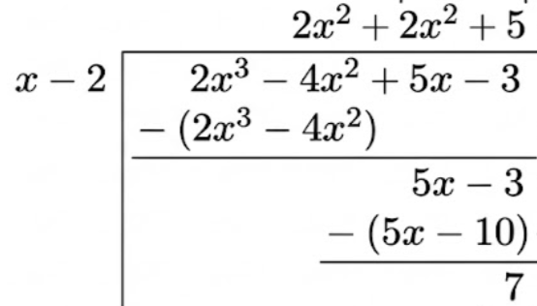
Ex impulse response: $H\left(s\right)=\frac{10s}{(s+4)(s+3)}=\frac{40}{s+4}+\frac{-30}{s+3}→inL→-30e^{-3t}+40e^{-4t}=h\left(t\right)\left(impulse response!\right)$
Step response: H(s)=$\frac{Y\left(s\right)}{U\left(s\right)}=\frac{Y\left(s\right)}{1/s}→y\left(t\right)=step response$
$$DC motor:output speed given voltage:\frac{Ω\left(s\right)}{V\left(s\right)}=\frac{K}{Τs+1}$$
non-minimum phase system = one or more zeros in the right-half plane (RHP)
$$Law of motors: F=BliN. F→mech force. B→mag flux density. l→length of conductor exposed to mag field.i→elec current through conductor$$
Law of generators: $e=Blv\text{ V}$. $e→$ induced voltage. $B→$ mag flux density. $l→$ length of conductor exposed to mag field. $v→$ velocity of conductor.
$$v=\dot{x};a=\ddot{x}$$
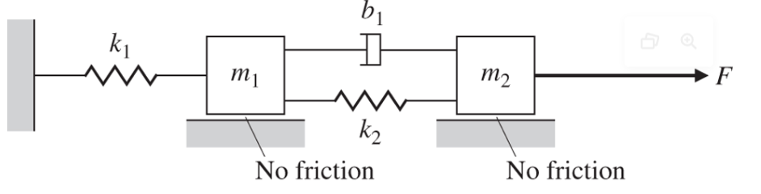
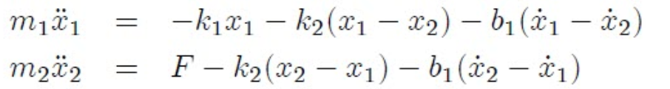
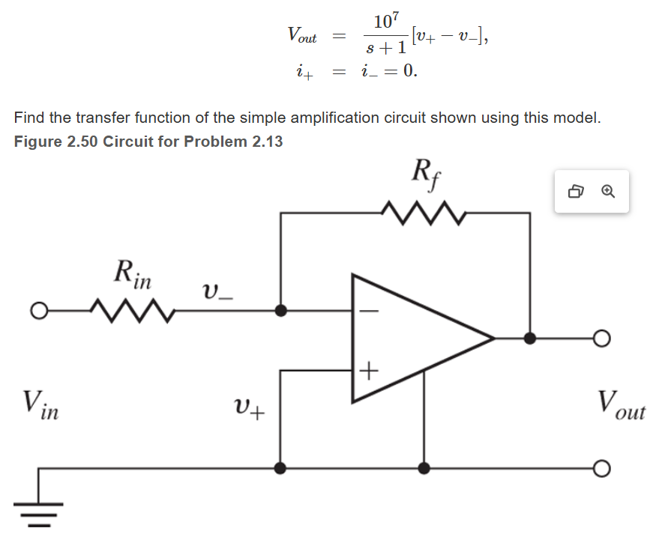
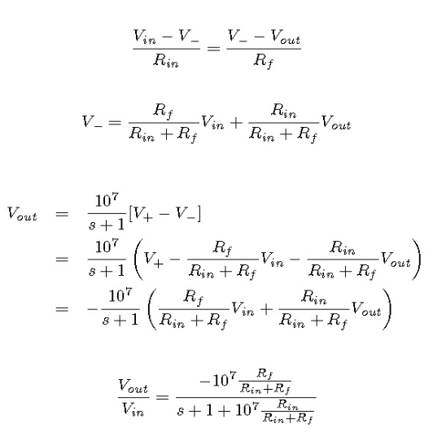
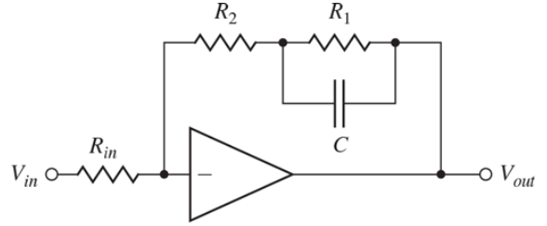
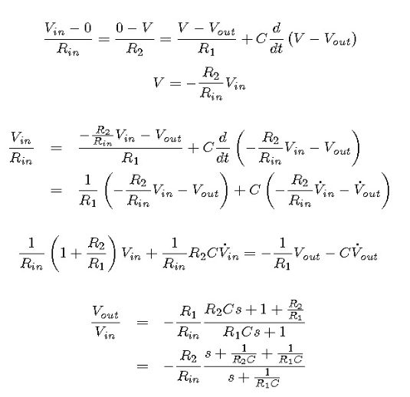
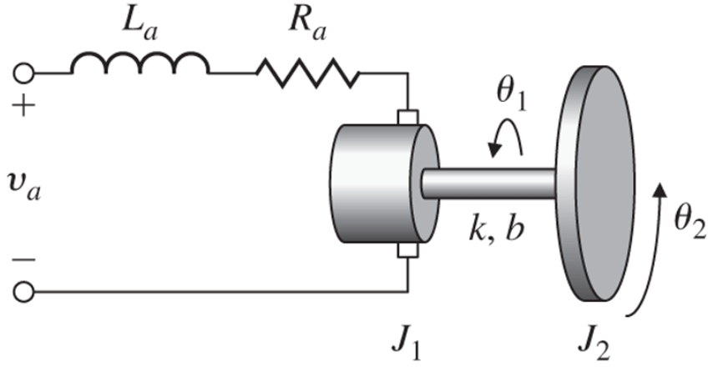
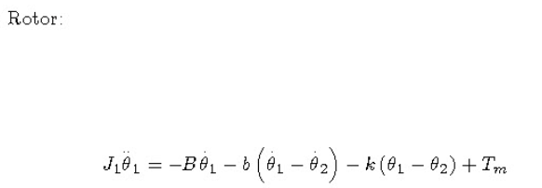
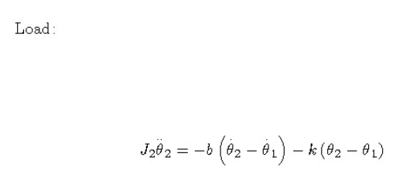
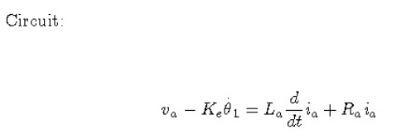
$$\frac{d}{dt}i_{a}→usually goes to 0$$
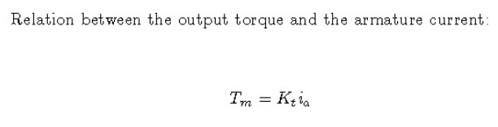
Sum of forces = ma
$$T_{motorFriction}=B\dot{θ}$$
$$T_{motor}=k_{t}i_{a};k_{t}=motor torque constant$$
$$V_{emf}=k_{e}\dot{θ};k_{e}=back emf constant$$
$$F_{spring}=-kx$$
$$F_{damper}=b\dot{x}$$
$newtons law for rotational motion:Τ=J\ddot{θ}$; J=moment of inertia; $\ddot{θ}=rotational accel$
Omp amp assumptions: $V_{p}=V_{n};I_{p}=I_{n}=0;Pos=leader;neg=follower$
Capacitor: $i=C\frac{dv}{dt}$; Inductor: $V=L\frac{di}{dt}$
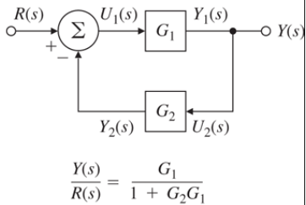
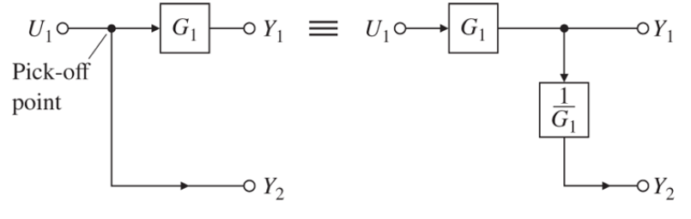
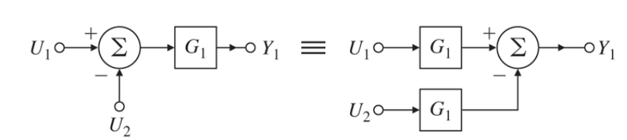
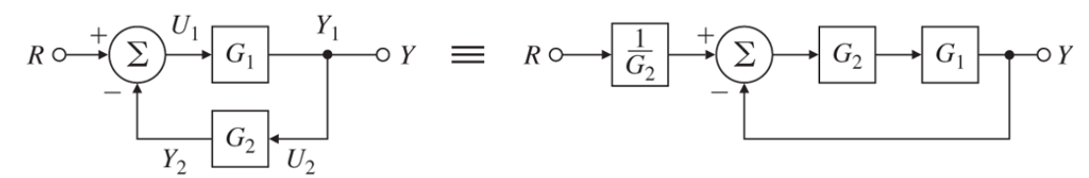
row of zeros in routh array = roots symmetrically about the origin, imaginary or real
Adding a pole at $s=0$ changes a system from one that reacts to current inputs into one that accumulates inputs over time. Adds integrator into controller.
If nodes have same start point and go into same summer, they can be combined into a single sum.
Steady state error: $y_{ss}=\lim_{s→0}{sY(s)}$, remember to include another 1/s if it is steady state error to a step response!
Settling time = 5 time constants ($Τ$)
Gain of a single loop NEG feedback system is given by the forward gain divided by the sum of 1 plus the loop gain.
Inv lap of transfer fun = impulse response
U(t)$→$invlap$→$1/s

